Skills Workshop # 2: Technical Writing & Presentation

Speaker: Dr. Margaret Kupferle, Associate Professor, Department of Chemical and Environmental Engineering, College of Engineering and Applied Science, University of Cincinnati
Date: Wednesday, July 10th, 2019
Time: 11:10 AM - 12 PM
Venue: University of Cincinnati, Baldwin Hall, room 741

Prepared by:
Elsheika Thompson, Beechwood High School, Fort Mitchell, Kentucky
RET Participant for Project #5: Secure Software Development

This Skills Workshop #2: Technical Writing and Presentation session was led by Dr. Margaret Kupferle, an Associate Professor at the University of Cincinnati. Dr. Kupferle currently teaches graduate and undergraduate courses in chemical and environmental engineering, including material and energy balances, solid and hazardous waste management, and honors classes in sustainable technology. Her primary research expertise is in the treatment of contaminated water and soil. She is particularly interested in chlorination chemistry, water reuse, electrochemistry and biofilms, supervising 12 MS thesis and 3 doctoral students to completion and currently advising 2 PhD and 3 MS students.

Prior to joining the tenure track faculty in 2004, Dr. Kupferle had a long contract research relationship with the U.S. EPA. While Assistant Professor, she received the NSF Early CAREER Award in 2008. She was promoted and tenured in 2011. She was a 2014 Fellow in the prestigious Executive Leadership in Academic Technology and Engineering program at Drexel University (ELATE at Drexel™, and she chairs the Environmental Engineering Program, serves as member of the Advancing Student Success in Engineering and Technology (ASSET) college committee, is a member of the ChEE departmental RPT committee, and advises the UC student chapter of Engineers Without Borders. Dr. Kupferle recently served as co-PI and Project Mentor for a 3-year summer NSF REU Site as well as the most recent 3-yr NSF RET Site. She is also Co-PI for the this new RET grant and will become the PI upon the retirement of the current PI.

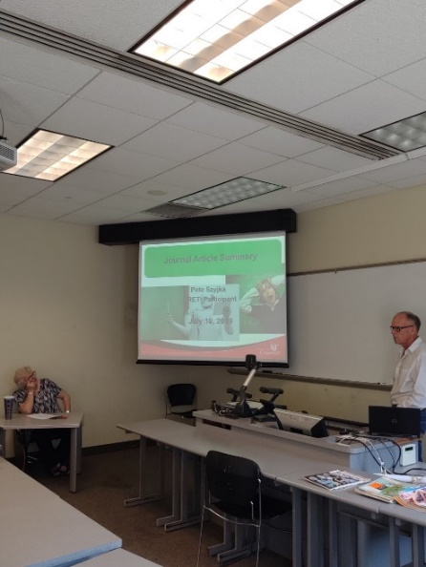
During a previous session, Skills Workshop #1, Dr. Kupferle shared opportunities for the 2019-2020 RET program cohort to disseminate information about the RET program as well as their implementation of the summer research into the classroom. In addition to the STEM Conference (a collaboration between NKU’s CINSAM and the University of Cincinnati’s Engineering Enhanced Math and Science Program) held this fall, she encouraged RET teachers to present at their school during departmental meetings or on Professional Development days, other local conferences held in the Cincinnati and Northern Kentucky area, and/or write a journal article.
Figure 1: Peter Szyjka sharing his Traveling Salesperson Problem presentation outline.

Today’s session, Skills Workshop #2, was a continuation of the previously mentioned one. Its purpose was to afford RET teachers the opportunity to present their individual initial ideas for disseminating information about their RET program experience and classroom implementation. The format/ agenda was quite simple; an RET teacher would present their idea as a PowerPoint and would be given feedback from Dr. Kupferle and their peers immediately following.

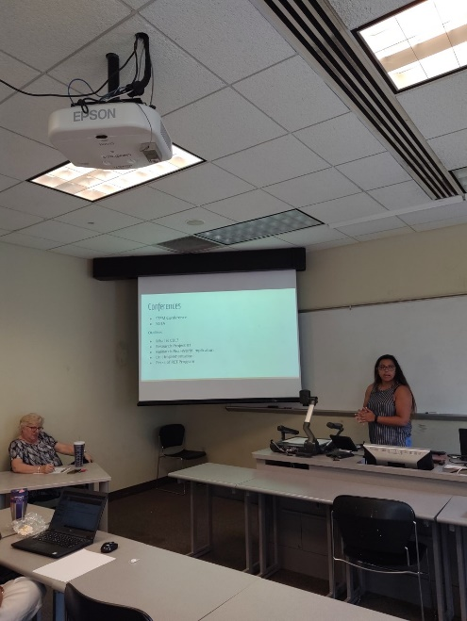
RET Teacher, Peter Szyjka, shared his plans to present on The Traveling Salesperson Problem possibly at a local conference, see Figure 1. His presentation primarily focused on the connection of his summer research to the College Algebra content and its implementation into the classroom through various student activities. Dr. Kupferle suggested that it might be more appropriate share information about the RET program and his experience in the Acknowledgements section rather than during the activities. This would allow for a better flow of the information being shared.

Following Peter Szyjka, was RET teacher, Megan Brown, who presented an outline for presenting on the summer research experience, see Figure 2. She explained that Project Based Learning is employed by teachers at her current school, however having learned more about Challenge Based Learning through the RET program has helped her to see more clearly the differences and benefits of both. She intends on sharing with colleagues more information about CBL, her summer research, and the unit designed as a result as well as its implementation. Brown noted that Dr. Kupferle’s earlier suggestion given to Szyjka to utilize the Acknowledgements to talk about the RET program, was also best for her when presenting at her school during a PD day. Additionally, she plans to write a journal article which focuses on the assessment results from her unit implementation.
Figure 2: Megan Brown presenting
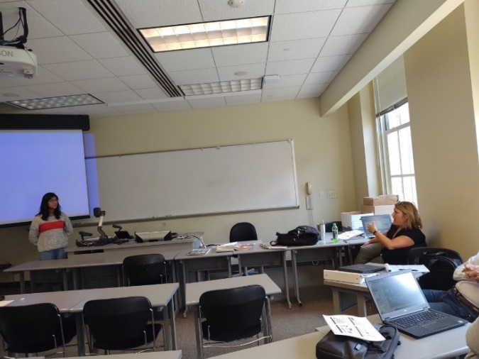
Akshayaa Venkatakrishnan’s presentation on ways to collaborate more with teachers at her school and to encourage them to buy into the idea of CBL mirrored the purpose of a few other RET teachers’ presentation. Venkatakrishnan plans to present during a Professional Development seminar at her school and believes that buying into CBL would allow for cross curricular units to be taught. Teachers would collaborate more and students would see the connection in content areas and information being learned in those classes. Lora Buchanan (Coordinator of the RET Program), see Figure 3, suggested that Venkatakrishnan include student feedback about engagement during the unit as this would get a lot of teachers to buy into the idea. She maintained that the difference in student performance can differ when moving away from the traditional paper and pencil.

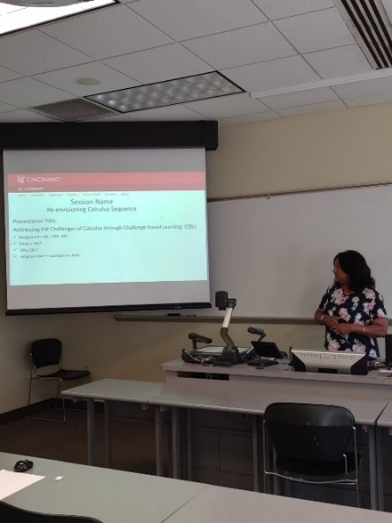
Girija Nair-Hart (a college Calculus Faculty), see Figure 4, shared her plans to present on the topic ‘Addressing the Challenges of Calculus 1 through Challenge Based Learning (CBL)’ and how actual application of the content learned can facilitate student understanding of the concepts. Girija Nair-Hart then shared with the other RET teachers the names of local conferences that she has presented in the past where high school teachers have presented as well. She encouraged them to present in one of the local conferenced mentioned and to possibly co-present with her about this summer’s research program and their classroom implementation.
Figure 3: Lora Buchanan giving feedback to Akshayaa Venkatakrishnan.

Having listened to everyone’s presentation and/or journal article ideas, it became evident that each of the high school teachers plans to present at their school either at a department meeting or during a PD day. Both college teachers and several high school teachers shared aspirations of presenting at a local conference and/or writing a journal article. Dr. Kupferle’s feedback given during this session was not focused on the aesthetics of the PowerPoint, but rather on the content to be shared. She encouraged RET teachers to be clear about their summer research and its connection to the content in which they teach, and offered ways to captivate their specific audience. As a result, RET teachers walked away with a clearer idea of how they were going to present their topic of choice
Figure 4: Girija Nair-Hart sharing a potential outline of her presentation
.

